3/19/2024

Dr. Aamir Farooqui

IoT MASTERCLASS Spring-'24

**Getting Started with ESP32 Arduino IDE Setup and Programming Tutorial**

**Introduction**

For ESP32 Programming, we can use Arduino IDE. This makes things easy for Arduino developers than learning a new language and IDE for ESP32.

**Step 1**

Download the latest version of Arduino Software from the following link and install it.

<https://www.arduino.cc/en/software>

**Step 2**

Open the Arduino IDE and **go to File**►**Preference** as shown in the below Figure1.

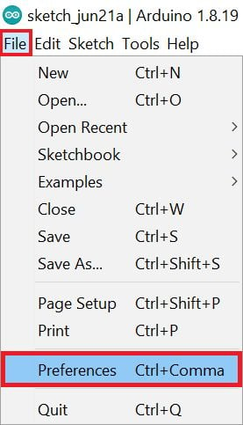

**Figure 1**

# Step 3

Now on the Preference window, Enter the below link in Additional Boards Manager URLs

<https://raw.githubusercontent.com/espressif/arduino-esp32/gh-pages/package_esp32_index.json>

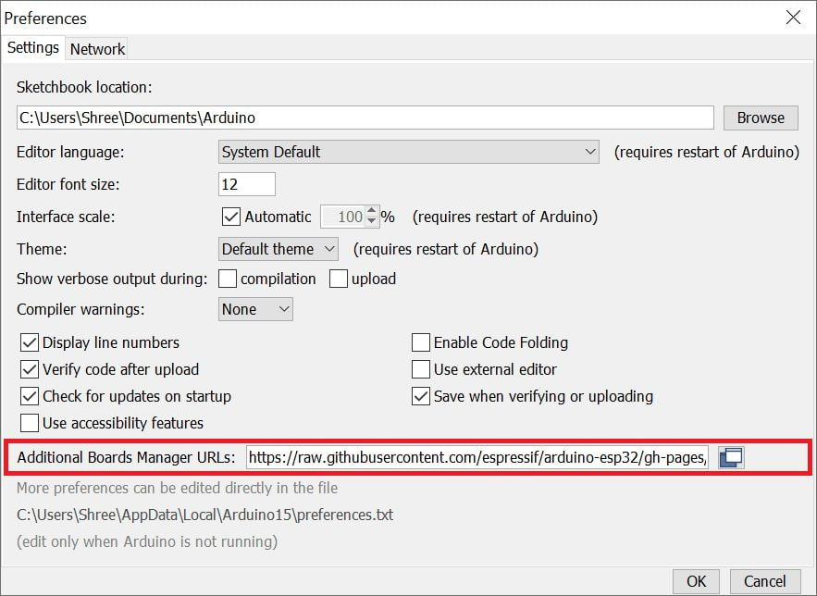

**Figure 2**

# Step 4

To add the ESP32 board go to the path **Tools ► Board ► Boards Manager…**

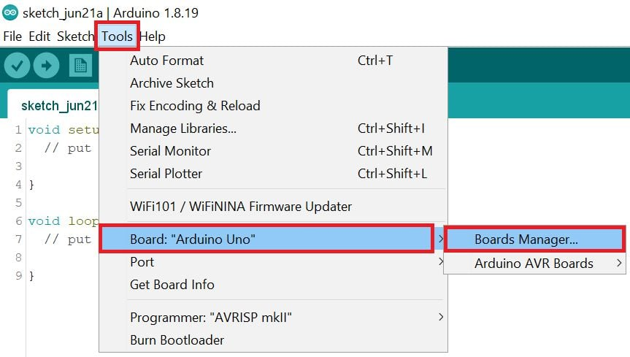

**Figure 3**

**Type on esp32** on the search bar and click on the install button.

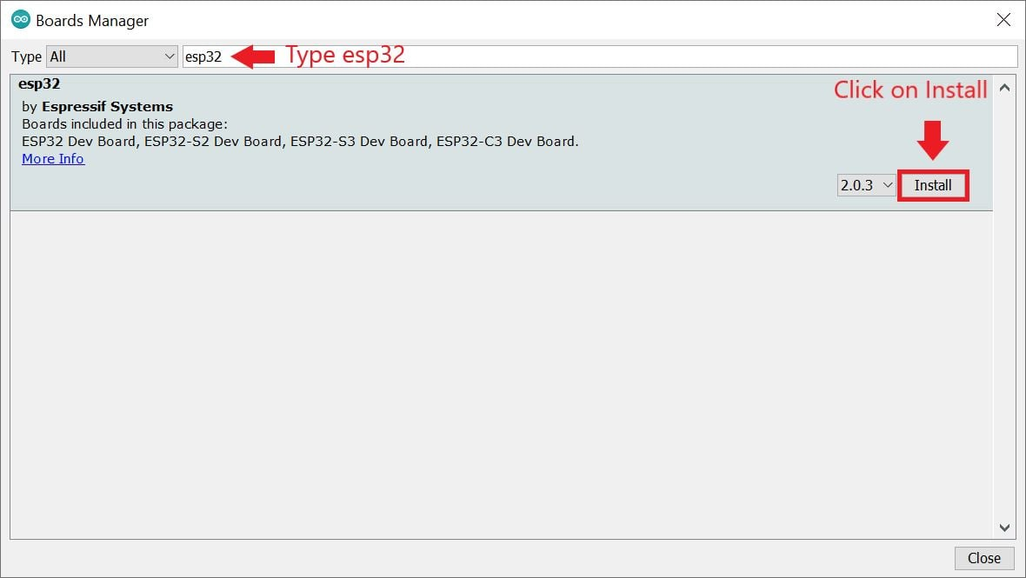

**Figure 4**

Wait for the installation.

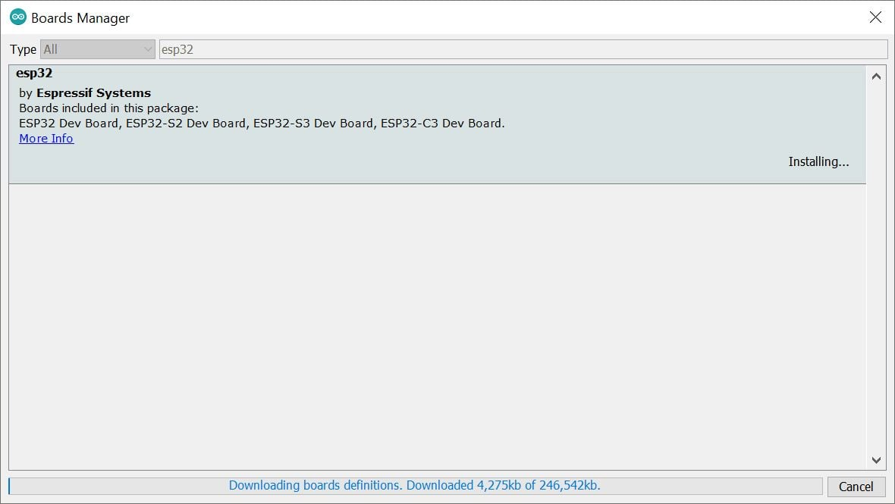

**Figure 5**

# Step 5

After board installation select the ESP32 board using the path **Tools ► Board ► ESP32 Arduino ► DOIT ESP32 DEVKIT V1**

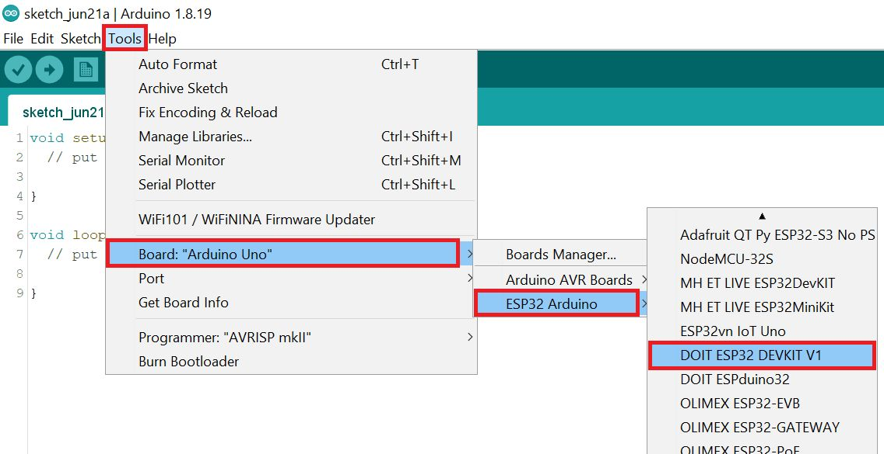

**Figure 6**

**Select the COM Port** using **Tools ► Port ► COM\***path. In our computer, the ESP32’s COM port shows COM5.

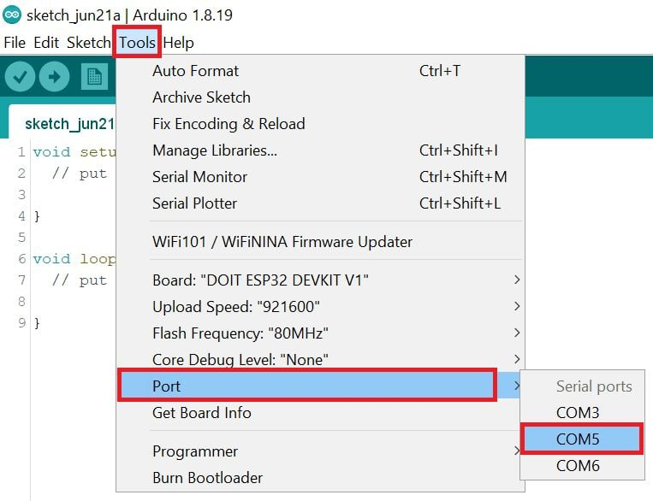

**Figure 7**

# ****Example****

Let’s see how to write a simple serial print sketch using Arduino IDE for ESP32.

First, connect ESP32 Development Kit to PC as shown in the below figure

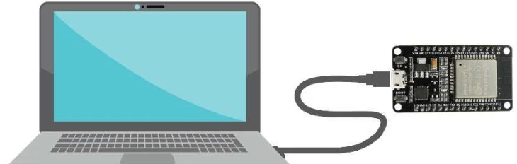

After setting up Arduino IDE for ESP32, **open Arduino IDE and write a simple sketch of the serial print** as shown in the below figure 8.

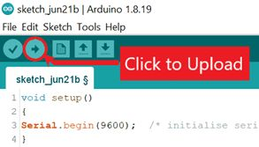

**Figure 8**

void setup()

{

Serial.begin(9600);  /* initialise serial communication */

}

void loop()

{

Serial.println("IoT MASTERCLASS Spring-'24"); /* print **IoT MASTERCLASS Spring-'24** at new line per second */

delay(1000);

}

Now **upload the code** using the upload button.

Note: Before uploading the code make sure the ESP32 board is in boot mode, to enter boot mode press the **boot** button press the **reset** button then release the **reset** button, and then release the **boot** button, and your board will go into boot mode

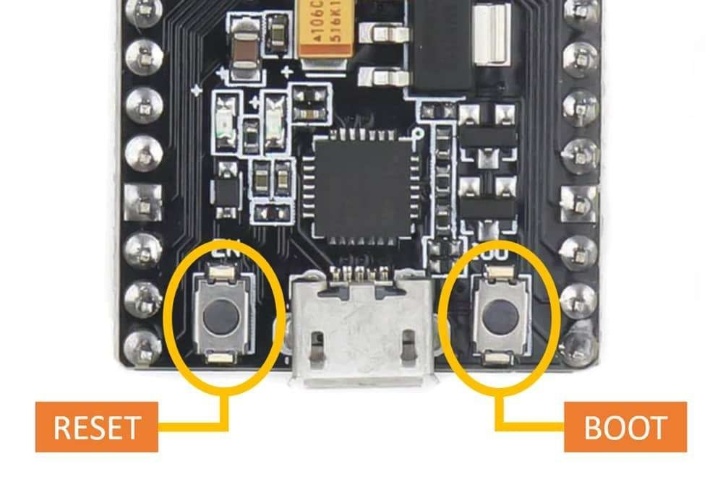 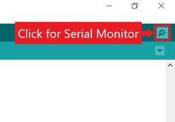

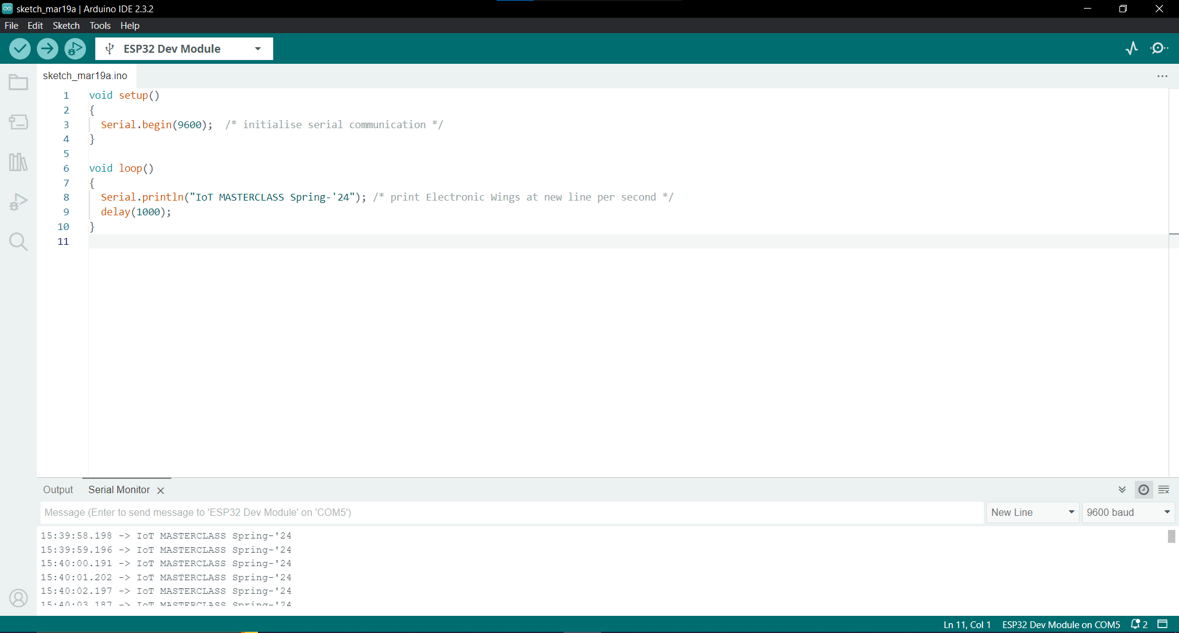

# ****ESP32 Troubleshooting Guide****

1. **Can’t detect the ESP32 board?**

* Check the USB cable connection properly (Sometimes Micro USB cable loose connected)
* Check whether the USB driver is installed or not in the device manager
* Check whether the PC or laptop USB port is working or not.
* Check the ESP32’s power supply.
* Check the ESP32 board is working or not.

1. **ESP32 Board detects but can’t program?**

* Check the correct COM port for ESP32 from the device manager and in Arduino IDE is the same.
* Check the selected board is ESP32.

1. **The settings for the ESP32 board are ok still can’t program the board.**

* Check whether the ESP32 board is in boot mode or not, sometimes we enter in boot mode, but it can’t go in boot mode because the buttons is tiny.
* Remove the USB cable from ESP32, reconnect the ESP32 board, and set it in boot mode.

1. **When connecting the USB cable to the ESP32 chip heat suddenly**

* If the board is short internally or externally then this issue occurs.
* Check the supply voltage, if the supply voltage is higher than the rated voltage then this issue also occurs.

Reference Link:

<https://www.electronicwings.com/esp32/getting-started-with-esp32>

# Create a Tinker cad Account

# When you sign up for a Tinkercad account, the login you create becomes your Autodesk ID, too, which means you can use the same login everywhere on all of the Autodesk websites. This is especially useful if you’re using other Autodesk applications, such as AutoCAD or Inventor because it gives you an identity on the [Autodesk user forums](http://forums.autodesk.com/) and on the [Autodesk Knowledge Network](http://knowledge.autodesk.com/), or AKN for short.

To create a Tinkercad account:

**1. Click Sign Up on the Tinkercad homepage.**

The Create Account dialog box, shown here, appears.

# 

**Figure 1**

**2. Choose your country from the drop-down list.**

In my case, that would be the United Kingdom. Yours may be different, such as the United States. The default country is the United States. That’s purely because Autodesk is an American company, with its headquarters in San Francisco, California.

**3. Enter your birthday.**

No, there’s no big party or cake (sadly), but you have to put in your birthday so that Autodesk knows whether you’re a child or an adult. Tinkercad is used by adults and children alike, and purely for precautionary purposes, they need to know your age.

**4. Click the Next button.**

The next Create Account dialog box, shown here, appears.

# 

**Figure 2**

**5. Add your email address and a password, accept the Tinkercad terms of service, and click Create Account.**

The confirmation screen shown here appears. The confirmation screen shows you that your Tinkercad account has been created. It also tells you that your Autodesk ID gives you access to many other Autodesk cloud-based products, including AutoCAD 360, A360, Fusion 360, and many others.

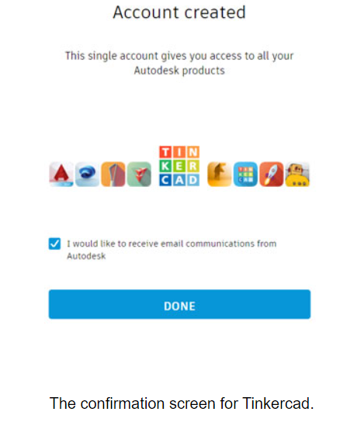

**Figure 3**

**6. If you want to receive email communication from Autodesk, select the permissions box and then click Done.**

A confirmation email is sent to the email you provided. And that’s it! You now have a Tinkercad account. Also, upon signing up you are automatically logged in to Tinkercad, too.

**Reference Link**

<https://www.dummies.com/article/technology/software/design-software/autocad/create-tinkercad-account-252952/>

TO CREATE AN ACCOUNT ON EASYEDA, YOU CAN FOLLOW THESE STEPS:

* Go to the EasyEDA Website: Visit the EasyEDA website by typing "EasyEDA" into your preferred search engine or by directly entering the URL: <https://easyeda.com/>.

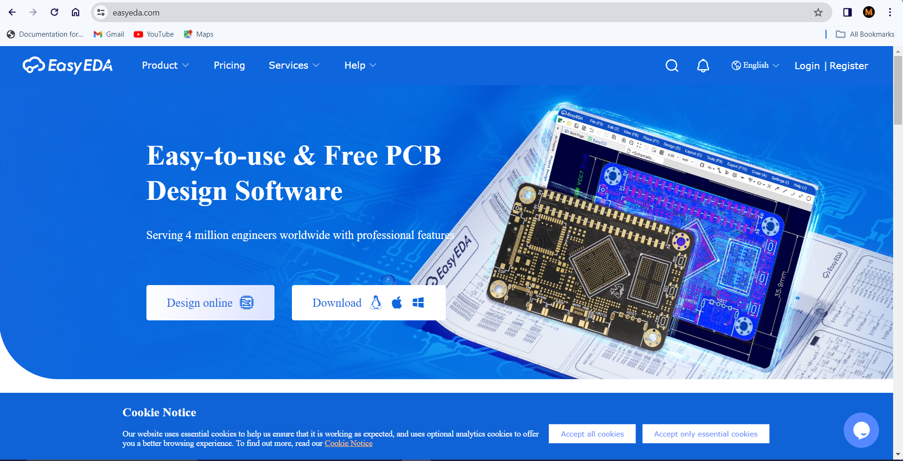

**Figure 1**

* Sign Up: Look for the "Sign Up" or "Register" button on the website's homepage, typically located at the top right corner or in the center of the page. Click on it.
* Fill Out the Registration Form: You'll be prompted to fill out a registration form. Typically, this form asks for basic information like your email address, username, and password. Enter the required details accurately.

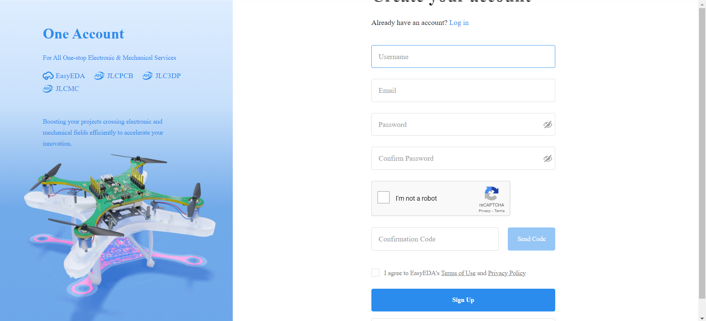

**Figure 2**

* Verify Your Email Address: After filling out the form, you may need to verify your email address. Check your inbox for an email from EasyEDA and follow the instructions provided to verify your email. Sometimes, the email might end up in your spam or junk folder, so be sure to check there if you don't see it in your inbox.
* Login: Once your email address is verified, return to the EasyEDA website and log in using the credentials you provided during the registration process.
* Complete Profile (Optional): You may have the option to complete your profile by adding additional information such as your full name, profile picture, etc. This step is often optional but can help personalize your account.
* Start Using EasyEDA: Once you're logged in, you can start using EasyEDA for electronic circuit design, PCB layout, and other related tasks.

That's it! You should now have an account on EasyEDA and be able to access its features and services.

**Reference Link**

<https://passport.easyeda.com/#/register?response_type=code&client_id=739ad3c2c22d424b9b2173a3737481af&redirect_url=https%3A%2F%2Feasyeda.com%2Flogin&state=1711215261&from=easyeda&scope=all>